

**AMERICAN INTERNATIONAL UNIVERSITY–BANGLADESH (AIUB)**

**FACULTY OF SCIENCE & TECHNOLOGY**

**DEPARTMENT OF PHYSICS**

**PHYSICS 1 LAB**

**Spring 2021-2022**

**Section: B19, Group: 03**

**LAB REPORT ON**

***(*a) Study of Ohm’s law using unknown resistances.**

**(b) Determination of the equivalent resistances for series and parallel combinations of resistors.**

**Supervised By**

**Md. Saiful Islam**

**Submitted By**

|  |  |  |
| --- | --- | --- |
| **Name** | **ID** | **Contribution** |
| **1. Sha Sultan Sowhan** | **22-47014-1** | **Result and Discussion** |
| **2. Mahmuda Khatun** | **22-47016-1** | **Procedure and Experimental data** |
| **3. Farjana Yesmin Opi** | **22-47018-1** | **Analysis and Calculation** |
| **4. Md. Abu Towsif** | **22-47019-1** | **Theory and Apparatus** |

Date of Submission: **March 31, 2022**

**TABLE OF CONTENTS**

|  |  |
| --- | --- |
| **TOPICS** | ***Page no*.** |
| 1. **Title Page** | **1** |
| 1. **Table of Content** | **2** |
| 1. **Theory** | **3** |
| 1. **Apparatus** | **4** |
| 1. **Procedure** | **4** |
| 1. **Experimental Data** | **5,6** |
| 1. **Analysis and Calculation** | **7,8** |
| 1. **Result** | **9** |
| 1. **Discussion** | **9** |
| 1. **References** | **9** |
|  |  |

1. **Theory**

Ohm's law states that the current through a conductor between two points is directly proportional to the voltage across those two points. Introducing the constant of proportionality, the resistance, one arrives at the usual mathematical equation that describes this relationship:

V = IR

where *I* is the current and V is the potential difference across the resistance R

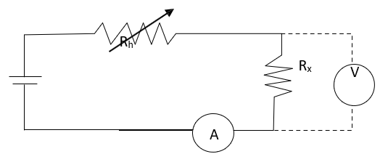

Slope = R

1. (b)

Figure 5.1: (a) Simple circuit to determine unknown resistance, Rx by using Ohm’s law, ammeter (A) and voltmeter (V) are used to measure the current and potential drop in the circuit, variable resistor, Rh is used to change the current flow in the circuit (b) Slope of the V vs I graph gives the value of R.

When *N* number of resistors are connected in series and parallel connections their equivalent resistances *Rs* and *Rp* are calculated by the following two equations:

Rs = R1 + R2 + . . . . .+ RN

= + + …...+

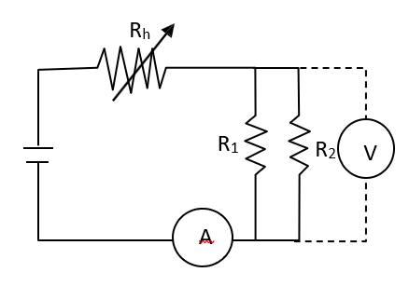

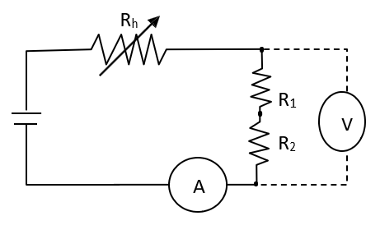

1. (b)

Figure 5.2: Series and parallel connections are shown for two resistors R1 and R2 in (a) and (b), respectively

1. **Apparatus**

1.Power Supply

2.Variable resistor

3.Ammeter

4.Voltmeter

5.Unknown resistors

6.Connecting wires

1. **Procedure**

1.First of all, we constructed above with 2 unknown resistances (R1 & R2 ).

2.By choosing Rh current not more than 1 A, we varied Rh to select 06 different currents through the circuit as measured by the ammeter A.

3.Then we measured the corresponding potential differences (V) in the voltmeter.

1. **Experimental Data**

Table 1: Voltage current records for R1 and R2

|  |  |  |
| --- | --- | --- |
| Resistors | Current  I  (A) | Voltage  V  (V) |
| R1 |
| 0.05 | 0.1546 |
| 0.10 | 0.3109 |
| 0.15 | 0.470 |
| 0.20 | 0.608 |
| 0.25 | 0.772 |
| 0.30 | 0.922 |
| R2 | 0.05 | 0.0478 |
| 0.10 | 0.0967 |
| 0.15 | 0.1429 |
| 0.20 | 0.1923 |
| 0.25 | 0.237 |
| 0.30 | 0.2916 |

Table 2:Voltage current records for series and parallel connestions

|  |  |  |
| --- | --- | --- |
| Combination of R1 & R2 | Current  I  (A) | Voltage  V  (v) |
| Series Combination | 0.05 | 0.2116 |
| 0.10 | 0.404 |
| 0.15 | 0.613 |
| 0.20 | 0.817 |
| 0.25 | 0.999 |
| 0.30 | 1.239 |
| Parallel Combination | 0.05 | 0.0365 |
| 0.10 | 0.0733 |
| 0.15 | 0.11 |
| 0.20 | 0.1467 |
| 0.25 | 0.1813 |
| 0.30 | 0.2148 |

1. **Analysis and Calculation**

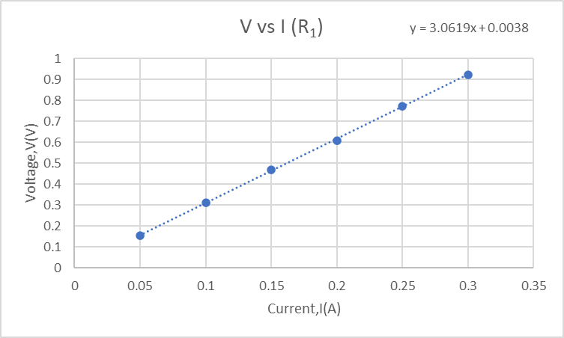

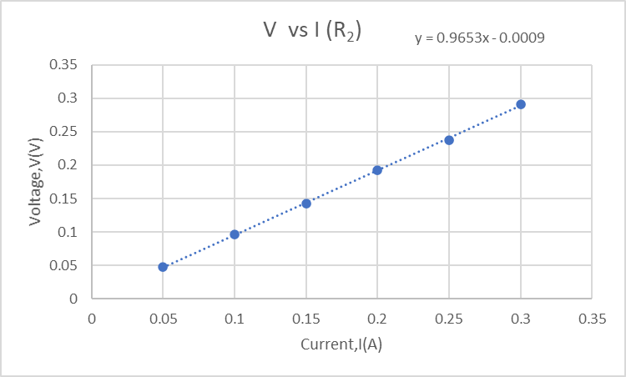

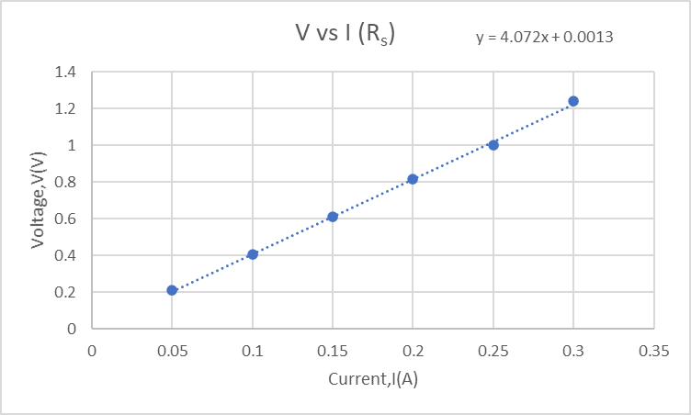

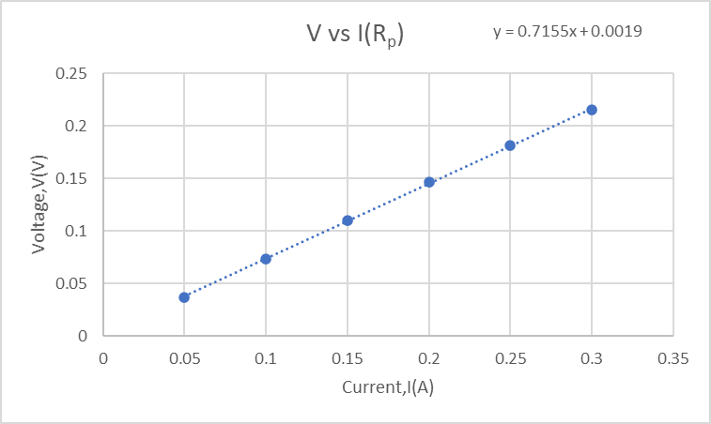

Calculating the values of Rs and Rp:

Rs = R1 + R2 =(3.0619 + 0.9653) Ω

Rs = 4.0272 Ω

$\frac{1}{Rp}$ = $\frac{1}{R1}$ + $\frac{1}{R2}$ =( $\frac{1}{3.0619}$ + $\frac{1}{0.9653}$) = 1.3625 Ω

Rp = = 0.7339 Ω

1. **Result**

|  |  |  |  |
| --- | --- | --- | --- |
| Resistances from the graphs | | Calculated  Values fo Rs  and Rp in ohms | Comments |
| Resistors | Values in Ohms | We got Rs = 4.072 Ω and Rp = 0.7155 Ω from the experiment. Hand calculated values ,Rs = 4.072 Ω and Rp = 0.7399 Ω .So we can say that the experiment is varified |
| R1 | 3.0619 |
| R1 | 0.9653 |
| Rs | 4.072 | 4.0272 |
| Rp | 0.7155 | 0.7339 |

1. **Discussion**

1.We got our values of Rs and Rp very close. But if you have taken more reading then our values would have more accurate.

2.We were careful about making the graphs.

3. If there is a constant resistance in the circuit, the current is directly proportional to the voltage and will increase as the voltage increases.

4.We took every reading carefully as well as every calculation.

1. **References**

**Fundamental of Physics (10th Edition)**: Ohm’s Law (Chapter 26, page 756-759)